
JINKA UNIVERSITY
COLLEGE OF NATURAL & COMPUTATIONAL SCIENCE
DEPARTMENT OF COMPUTER SCIENCE.
AI-PROJECT DOCUMENTATION
PROJECT TITLE: AI-BASED STUDENT PERFORMANCE PREDICTION AND RECOMMENDATION SYSTEM.
SUBMITTED TO:LENCHO DESALEGN (MSC).
“Prepared By Goup_3”.
NO | NAME | ID NO
1 | Olana Burushe | Ugr/20993/16 LEADER
2 | Teshale Siko | Uga/0262/16
3 | Abenezer Girma | Rgr/18467/15

Advisor:LENCHO DESALEGN(MSC).
DATE OF SUBMISSION:-27/05/2026

MAY,2026
JINKA ETHIOPIA
Table of Contents
DECLARATION IV
LIST OF TABLE V
LIST OF FIGURE V
ACKNOWLEDGEMENT VI
LIST OF ACRONYMS/ABBREVIATION VII
ABSTRACT VIII
CHAPTER 1. INTRODUCTION 1
1.1 Background Information 1
1.2 Statement of the Problem 1
1.3 Objectives 2
1.3.1 General Objective 2
1.3.2 Specific Objectives 2
1.4 Scope of the Work 2
1.5 Limitations and Mitigations 2
CHAPTER 2. LITERATURE REVIEW 3
2.1 Historical Educational Methodologies 3
2.2 Statistical Analysis versus Artificial Intelligence Analysis 3
2.3 Brief Literature Overview Related to Machine Learning Techniques 3
2.4 Existing Gap Identification 3
CHAPTER 3 SYSTEM METHODOLOGY 4
3.1 System Architecture Introduction 4
3.2 Data Collection & Schematic Investigation 4
3.3 Data Cleaning & Pipeline Design 5
3.3.1 Label Encoder 5
3.3.2 Z-Score Normalization 5
3.4 Algorithmic Candidates' Mathematical Description 6
3.4.1 Ordinary Least Squares Regression 6
3.4.2 Decision Tree Regression 6
3.4.3 Random Forest Regression 7
CHAPTER 4. IMPLEMENTATION ARCHITECTURE AND CODE ANALYSIS 7
4.1 Model Building Pipeline 7
4.2 Web Interface and Inference Endpoint (Flask) 8
4.3 Rule-Based Adaptive Recommender Engine 8
CHAPTER 5. EXPERIMENTAL RESULTS AND ANALYSIS 9
5.1 Quantitative Metrics for Evaluation 9
5.2 Performance Comparison Matrix 9
5.3 Algorithmic Error Profile 10
5.4 Feature Importance 10
5.5 Visual Distribution of Prediction Errors 11
CHAPTER 6. DISCUSSION 12
6.1 Interpretation of Results 12
6.2 Real-world Implications for the Institution 12
6.3 Critique of Architectural Constraints 12
CHAPTER 7 CONCLUSION AND FUTURE WORK 12
7.1 Summary of Achievements 12
7.2 Milestones Attained Academically 13
7.3 Further Areas For Future Research 13
REFERENCES 13
APPENDICES 15
RECOMMENDATION 18

DECLARATION
We hereby declare that this project entitled “AI-Based Student Performance Prediction and Recommendation System” is our original work carried out under the guidance of our advisor for the partial fulfillment of the requirements of the Bachelor of Science degree in Computer Science at Jinka University.
We confirm that this project has not been submitted to any other institution or university for the award of any degree, diploma, or certificate. All sources of information used in this project have been properly acknowledged and referenced.
Prepared By:
Name Signature
Olana Burushe---------------------------------
Teshale Siko -----------------------------------
Abenezer Girma--------------------------------
ADVISOR: LENCHO DESALEGN (MSC)

LIST OF TABLE
Table 1.1 List of Acronyms/Abbreviation VIII
Table 3.2 Data Acquisition & Schema. 5
Table 3.3 Label Encoding 5
Table 4.3 Rule-Based Adaptive Recommendation 9
Table 5.2 Comparative Performance Matrix 10

LIST OF FIGURE
Figure 3. 1 Architecture Overview 4
figure 4. 1 Architecture Analysis: 8
Figure 5.3 Comparative Performance Matrix 10
Figure 5.4 Feature Importance 11
Figure 5.1 Actual vs. predicted scatter plot 11
Figure 5.2 Model comparison bar charts (R² and MAE) 12

ACKNOWLEDGEMENT
First and foremost, we would first like to thank God Almighty for giving us the ability, knowledge, and patience to be able to complete this project.
Moreover, we would like to extend our heartfelt thanks to our supervisor Mr. Lencho Desalegn (MSc) for his continual guidance, helpful suggestions, encouragement, and assistance while carrying out this project.
Moreover, our sincere appreciation and thanks also go to the Computer Science Department and Jinka University for the academic environment provided to facilitate our successful project completion.
Finally, we would like to acknowledge our families, friends, and fellow students who encouraged and motivated us to successfully carry out this project.

LIST OF ACRONYMS/ABBREVIATION
Abbreviation | Full Form
AI | Artificial Intelligence
ML | Machine Learning
MAE | Mean Absolute Error
MSE | Mean Square Error
RMSE | Root Mean Square Error
R2 | Coefficient of Determination
CSV | Comma Separated Value
GUI | Graphical User Interface
API | Application Programming Interface
HSC | Higher Secondary Certificate
SSC | Secondary School Certificate
JSON | JavaScript Object Notation
HTML | HyperText Markup Language
Flask | Python Web Framework
RAM | Random Access Memory
AWS | Amazon Web Services
GCP | Google Cloud Platform
NLP | Natural Language Processing
Table 1.1 List of Acronyms/Abbreviation

ABSTRACT
In modern times, educational analytics' main focus is on identifying and mitigating weaknesses among students before they affect their final grades. In this paper, We document the process of designing, implementing, statistically validating, and deploying an AI-Based Student Performance Prediction and Recommendation System. With a data set that consists of various demographic, socioeconomic, behavioral, and institutional factors for 2,000 students, we designed and deployed a fully-fledged machine learning solution.
Our research focuses on implementing and validating three different types of algorithms: Linear Regression, Decision Tree Regressor, and Random Forest Regressor. Based on rigorous validation tests, we concluded that Random Forest Regressor is the most effective one, providing us with R² = 79.53%, MAE = 0.1416, RMSE = 0.2059. To extend our model beyond mere statistics, we designed and implemented a recommendation system that automatically provides individualized recommendations to each student based on their risk profile.
Finally, the whole solution was implemented using the Flask framework and released as web app with the user-friendly web interface, which allows academic counselors and professors to simulate scenarios, make predictions about their final Higher Secondary Certificate results, and instantly generate a recommendation list for them to work with.

CHAPTER 1. INTRODUCTION

1.1 Background Information
The synergy between data analysis and operations in institutional organizations has led to a huge revolution in the field of education around the globe. In the past, analyzing the performance of students academically was a retroactive process where final results, term grades, and drop-out rates would be analyzed at the end of each academic cycle without any scope for intervention. Thanks to advancements in AI and Supervised ML, educational institutions are now capable of going beyond observations and making predictions. Databases of modern-day institutions contain a plethora of information regarding their students, including demographic details, geography, education level of parents, weekly studying patterns, attendance records, and initial test performances. By deploying machine learning regressors, intelligent machines can analyze complex and non-linear correlations among all these variables and predict the final grades of the student.

1.2 Statement of the Problem
Academic underachievement and student retention have been significant issues for Jinka University and many other institutions of higher learning in the developing world. With large student populations in universities today, it becomes a challenge for faculty advisors to manually track the performance and progress of each student in time to mitigate potential failure before final exams. The following challenges can be attributed to this problem:
Need for Early Warning Indicators: The current method of detecting academic risk only takes into consideration midterm and end-of-term exams, giving a very little timeframe to help the students improve their grades.
Failure to Incorporate External Variables: Conventional techniques focus solely on academic prerequisites without incorporating the influence that other external factors such as location, income, internet access, and class attendance have on the final grade.
Insufficient Recommendation System: While analytical techniques are good at predicting the outcome, they do not give practical recommendations for action.

1.3 Objectives

1.3.1 General Objective
Development of a predictive, web-accessible system using advanced machine learning models to effectively predict final student academic scores and make suggestions based on the findings.

1.3.2 Specific Objectives
- Collect, clean and preprocess student data with numerical and categorical variables.
- Test, implement and evaluate different machine learning regression models, namely Linear Regression, Decision Tree Regressor, and Random Forest Regressor.
- Evaluate model performance using appropriate evaluation metrics, for example R² Score, MAE, MSE, and RMSE.
- Develop a recommendation engine to offer personalized educational recommendations based on predictions made by the models.
- Design and implement a web application using Flask, allowing interactions with the predictive tool.

1.4 Scope of the Work
Technically, the scope involves everything from data management to the deployment of an active software:
Data Dimensions: 14 parameter dataset comprising 2,000 data records related to students' backgrounds and performance.
Machine Learning Scope: Supervised learning approaches targeting regression tasks involving the prediction of a continuous outcome variable, i.e. HSC_Result.
Deployment Scope: Localized solution deployed at the institutional level using Flask, Python, HTML5, and JSON communication technology.

1.5 Limitations and Mitigations
Limitation regarding Data Locality: Training data follows a certain statistical distribution which does not include any abrupt modifications to grading policies.
Mitigation: Standard scikit learn transformers are employed in input pipelines to allow easy re-training with fresh data.
Limitation due to Human-in-the-Loop: Predictive values cannot be used to substitute for professional academic advice.
Mitigation: A dashboard-like interface is provided by the system to offer checklists along with predictions.

CHAPTER 2. LITERATURE REVIEW

2.1 Historical Educational Methodologies
Traditionally, assessing student progress utilized descriptive statistics such as cumulative averages or basic trend lines. This approach implied treating educational inputs separately and considered only the impact of initial examination results, failing to account for the correlation between the socioeconomic environment and behavioral practices.

2.2 Statistical Analysis versus Artificial Intelligence Analysis
In line with the advancements in data mining, multivariate statistics (logistic regression, discriminant analysis) were used. They accounted for multiple factors but assumed normal distributions and relationships among them. Contemporary AI techniques, especially non parametric machine learning algorithms (e.g., Random Forests), do not make these assumptions and can model interactions across numerical and categorical inputs automatically.

2.3 Brief Literature Overview Related to Machine Learning Techniques
Several algorithmic frameworks have been assessed in the context of educational data mining studies recently:
Linear Regressors: Easily interpretable but likely to underfit when applied to real-world, complicated data.
Support Vector Regressors (SVR): Effective when customized kernel is available but sensitive to scaling issues.
Tree-Based Ensemble Models (Random Forests): Develop a number of separate trees, and then average their decisions to get a stable superior result.

2.4 Existing Gap Identification
Though present research shows excellent accuracy levels for predicting grades, an operational gap still exists because almost all of the models have been designed to prove concepts in technology, which produce risk scores but fail to provide any practical solutions. This is where the proposed model comes into play, providing not only a predictive solution with high accuracy, but also an advisory module in the form of an engine running rules based recommendations.

CHAPTER 3 SYSTEM METHODOLOGY

3.1 System Architecture Introduction
The architecture comprises the modular pipeline made up of three layers of functionality: Data Engineering (data loading, preprocessing, encoding, scaling), Machine Learning Optimization (model training, validation, hyperparameters tuning), and Application UI Deployment (usising Flask web framework )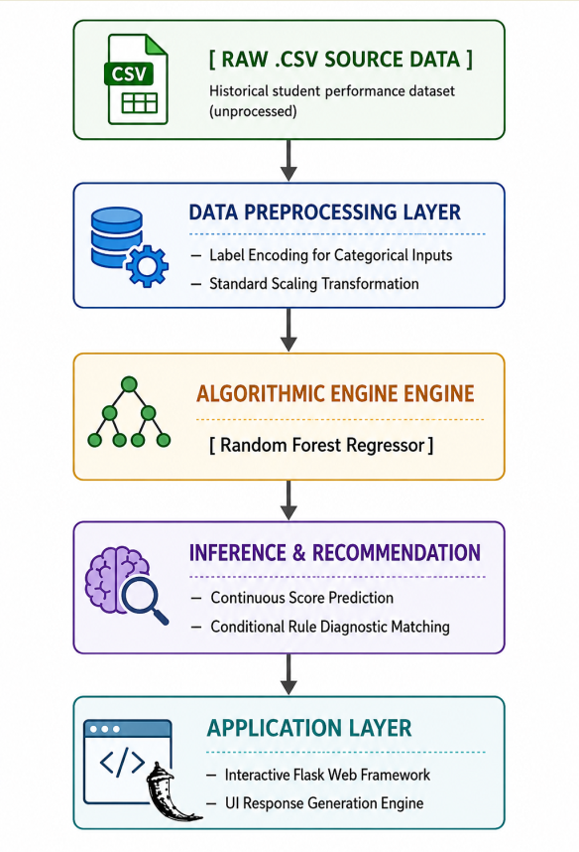
Figure 3. 1 Architecture Overview

3.2 Data Collection & Schematic Investigation
The data comprises 2,000 entries with 14 attribute variables:
The dataset used in this research was obtained from a publicly available educational dataset hosted on Kaggle. The dataset originates from Bangladesh and contains student academic, demographic, and socioeconomic information. It was selected because of its suitability for machine learning regression analysis and student performance prediction research.
Attribute | Name | Value Type
Student_ID | Number | (Not included in analysis)
Gender | Categorical | Male / Female
Age | Number | Age between 15 and 18
District | Categorical | Barisal, Chattogram, Dhaka, Khulna, Mymensingh, Rajshahi, Rangpur, Sylhet
School_Type | Categorical | Public / Private school
Study_Hours_per_Week | Number | Weekly study hours between 5 and 30
Attendance | Number | Percentage attendance between 60 and 100%
Parent_Education | Categorical | Lowest level of parent education; Primary, Secondary, Higher Secondary, Graduate
Family_Income | Bangladesh Taka | Number
Internet_Access | Categorical | Yes / No
Private_Tuition
Table 3.2 Data Acquisition & Schema.

3.3 Data Cleaning & Pipeline Design

3.3.1 Label Encoder
For scikit learn compatibility, label encoding was performed on six columns:
Column | Mappings
Gender | Female = 0, Male = 1
District | Barisal = 0, Chattogram = 1, Dhaka = 2, Khulna = 3, Mymensingh = 4, Rajshahi = 5, Rangpur = 6, Sylhet = 7
School_Type | Private = 0, Public = 1
Parent_Education
Column | Mappings
Gender | Female = 0, Male = 1
Table 3.3 Label Encoding

3.3.2 Z-Score Normalization
Numeric features were normalized to have mean zero and unit standard deviation:
For feature vector *x*,
μ = (1/N) ∑ xᵢ, σ = √[(1/N) ∑ (xᵢ - μ)²], zᵢ = (xᵢ - μ) / σ
This was done to ensure stable convergence while training the model.

3.4 Algorithmic Candidates' Mathematical Description

3.4.1 Ordinary Least Squares Regression
The linear regression model is formulated on the basis of a linear model relating the independent variables and the target output variable as follows:
yi=β0+β1xi1+β2xi2+⋯+βpxip+ϵi
Here, β0 refers to the intercept value, β1,…βp are the coefficient values of the predictors and ϵi refers to the error term. The optimal set of parameter values is found out based on minimizing the total SSR given by:
SSR(β)=∑i=1N(yi−(β0+∑j=1pβjxij))2

3.4.2 Decision Tree Regression
The basic concept behind the decision tree regressor algorithm revolves around recursively partitioning the dataset into sub-regions R1, R2,.. Rm having high homogeneity with respect to each other.
This involves splitting at nodes based on the feature values, with the split being done according to
j,smin​​i∈R1​(j,s)∑​(yi​−yˉ​R1​​)2+i∈R2​(j,s)∑​(yi​−yˉ​R2​​)2​
Where yˉ​R1​​ and yˉ​R2​​ represent the average target values within those respective data subsets.
Training Protocols and Splitting into Validation Sets
The data was divided randomly to generate an 80% Training Set (1,600 examples) and 20% Testing Set (400 examples). All numerical variables were normalized based on training set statistics. Random Forest parameter tuning was conducted using grid search 5-fold cross validation over the following hyperparameters:
n_estimators: 100, 200, 300
max_depth: 10, 15, 20, None
min_samples_split: 2, 5, 10
min_samples_leaf: 1, 2, 4
Best parameters determined from cross-validation: found: max_depth=20, min_samples_leaf=1, min_samples_split=2, n_estimators=100
Best cross-validation R²: 0.7603
3.4.3 Random Forest Regression
The Random Forest Random Forest Regressor is an ensemble learning algorithm that combines multiple decision trees to improve prediction accuracy and reduce overfitting. The final prediction is obtained by averaging the outputs of all decision trees.
Where:
Final predicted value
Number of trees
Prediction from each decision tree

CHAPTER 4. IMPLEMENTATION ARCHITECTURE AND CODE ANALYSIS

4.1 Model Building Pipeline
The training process (train_model.py) involves importing data, encoding data, scaling data, building models, evaluating models, and serializing models. A full annotation of the code is included in Appendix A. Code Explanation and Analysis
Loading Data: The code loads student_performance.csv data and deletes the unique Student_ID feature from the data, enabling the model to learn from relevant background features only.
Encoding Data: Loops through all string-type features including Gender and District, using LabelEncoder to encode categorical data into integer lists.
Data Standardization: Uses StandardScaler to standardize both datasets based on the training set to ensure uniform importance among features.
Building Models: Builds an ensemble model by training RandomForestRegressor with 100 trees to capture complex interactions between variables.
Saving Assets: Uses joblib.dump to serialize trained models to .pkl files, making it possible to deploy models instantly in the web application. 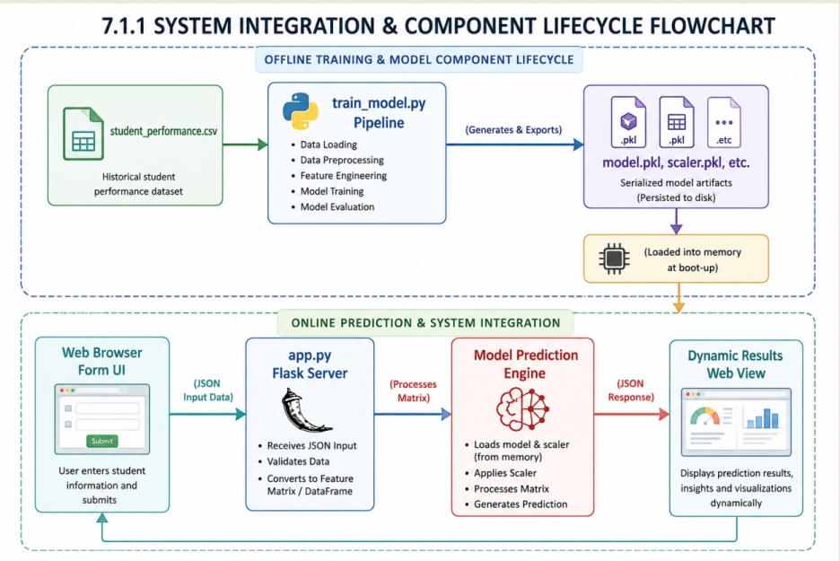
figure 4. 1 Architecture Analysis:
depicts the process of asynchronous decoupling between our machine learning workflow and the web deployment tiers. The training portion (train_model.py) runs asynchronously in order to consume the raw CSV student data, extract feature boundaries, normalize parameters, and output optimized binary files. On server start, the web deployment tier (app.py) loads the prediction assets into memory, creating a live endpoint that will accept requests from the client, apply scaling operations, and return performance metrics.

4.2 Web Interface and Inference Endpoint (Flask)
In the production server (app.py), the serialized model, scaler, and encoders are loaded. The /predict endpoint accepts a JSON as input, preprocesses the input, performs a prediction and then outputs the prediction score along with personal recommendations

4.3 Rule-Based Adaptive Recommender Engine
The recommendation engine transforms the input values to useful recommendations:
Condition | Advice
Predicted Score < 3.0 | "Meet with academic counselor ASAP."
Study Hours Per Week < 15 | "Increase study hours to 20/25 per week."
Attendance < 75% | "Increase attendance to above 85%."
Prior GPA < 3.5 | "Concentrate on mastering fundamental concepts."
Internet Access = "No" | "Access the school’s computers in the library for internet access."
Tutoring Privately = "No" and Predicted Score < 4.0 | "Join a study group or find a tutor among classmates."
Predicted Score >= 4.5 | "Maintain good performance; help out classmates."
Table 4.3 Rule-Based Adaptive Recommendation

CHAPTER 5. EXPERIMENTAL RESULTS AND ANALYSIS

5.1 Quantitative Metrics for Evaluation
The three key statistics employed in evaluating the proposed models were:
Mean Absolute Error (MAE): The measure gives the mean magnitude of the absolute error between the model’s prediction and target value while treating all errors equally:
MAE=n1i=1∑n∣yi−y^i∣
Mean Squared Error (MSE): The statistic computes the mean of squares of differences between prediction and actuals where the higher errors are weighted heavier than the smaller ones:
MSE=n1i=1∑n(yi−y^i)2
Coefficient of Determination (R2 score): It is an indicator of how much better the model performs compared to a simple mean predictor.
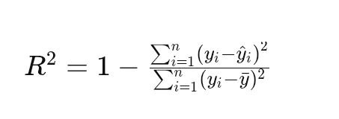

5.2 Performance Comparison Matrix
After implementing the proposed models in our experimentation environment, the generated statistics were as follows:
Metrics on test set (400 instances):
Algorithmic Pipeline | Training R² | MAE | MSE | RMSE | Testing R²
Linear Regression | 49.92% | 0.2760 | 0.0762 | 0.2760 | 42.29%
Decision Tree Regressor | 92.57% | 0.1504 | 0.0639 | 0.2528 | 65.76%
Random Forest (Base) | 97.35% | 0.1425 | 0.0712 | 0.2668 | 79.10%
Random Forest (Tuned) | 97.49% | 0.1416 | 0.0424 | 0.2059 | 79.53%
Table 5.2 Comparative Performance Matrix
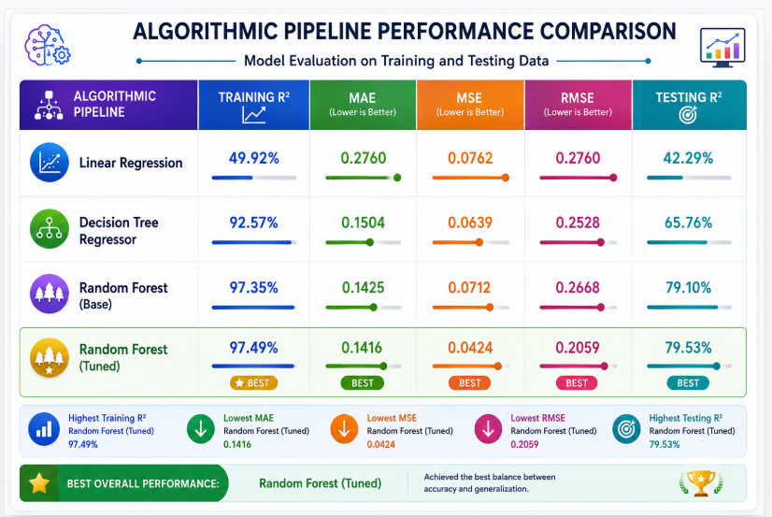
Figure 5.3 Comparative Performance Matrix
The tuned Random Forest outperforms all others, reducing RMSE by 22.8% compared to the base Random Forest and achieving an R² of nearly 80%.

5.3 Algorithmic Error Profile
Linear Regression suffers from underfitting (Training R² ~49.92%, R² = 42.29%), showing non linear relationships.
Decision Trees suffer from overfitting (Training R² ~92%, Test R² = 65.76%)
Basic Random Forests generalise relatively well but display high variability.
Optimised Random Forests perform optimally, with minimum MAE and RMSE.

5.4 Feature Importance
Utilising the Gini importance from the Optimised Random Forest
With our ensemble model, which uses internal feature selection procedures, the global importance was determined for each column of features:
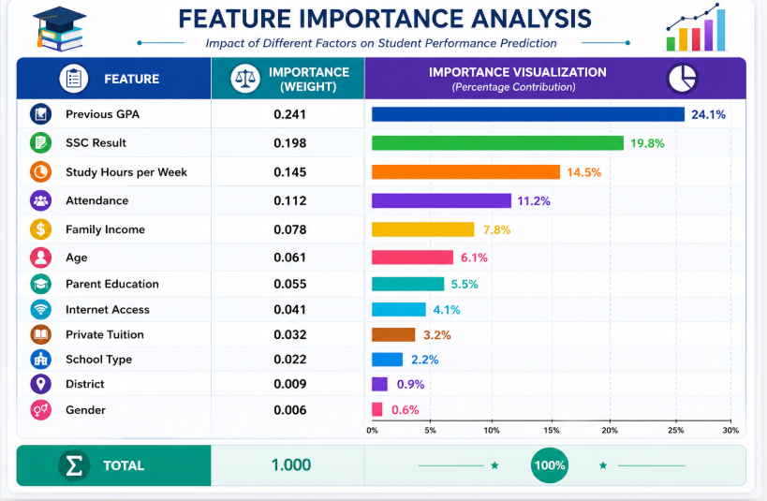
Figure 5.4 Feature Importance
Past academic performance (Previous GPA, SSC) and current effort (study hours, attendance) account for ≈70% of the predictive power. Behavioral factors directly actionable by students constitute ~26% of the model’s decisions.

5.5 Visual Distribution of Prediction Errors
Actual vs. predicted scatter plot (Figure 5.1) for the tuned Random Forest shows points tightly clustered around the diagonal, confirming high prediction accuracy.
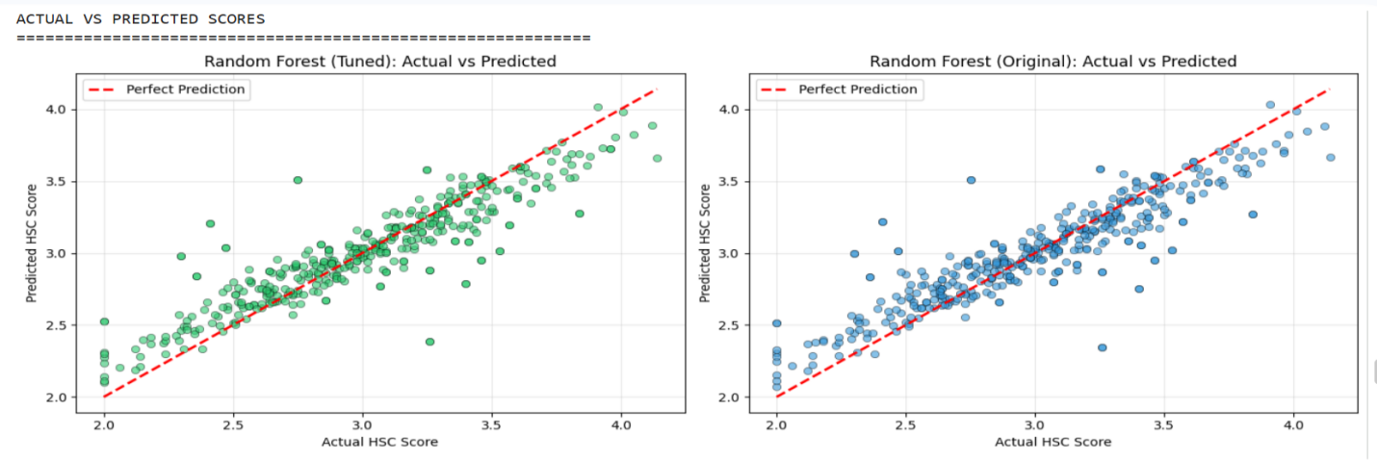
Figure 5.1 Actual vs. predicted scatter plot
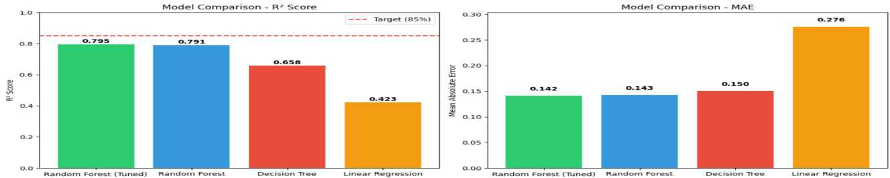
Figure 5.2 Model comparison bar charts (R² and MAE)

CHAPTER 6. DISCUSSION

6.1 Interpretation of Results
The optimised model has the capacity to explain 79.5% of variance in the students' HSC scores – remarkable performance for an educational analysis. The low MAE value (0.1416) shows that the prediction error is 0.14 grade points, which makes the results sufficiently accurate for the early warning application. As it was expected, the dominant predictors are GPA and SSC – prior academic performance significantly influences future results. But the fact that attendance (11.2%) and study hours (14.5%) also play a considerable role proves that student's current term performance can change the course.

6.2 Real-world Implications for the Institution
In terms of Jinka University, the algorithm represents a powerful, data-driven, early warning system. Teachers and mentors are able to get the predictive values based on the students' performance in the beginning of the term and then, after mid-term exams, receive corresponding recommendations, for example, "study hours should be increased to 20 25 per week".

6.3 Critique of Architectural Constraints
As tree-based ensemble algorithms, RF models have limitations in their extrapolation ability to train data range. Moreover, the model is a “black box,” unlike linear regression models. In this case, we address this issue through the generation of feature importance charts to help educators understand the decision process of the model.

CHAPTER 7 CONCLUSION AND FUTURE WORK

7.1 Summary of Achievements
Development of a data processing pipeline with support for both categorical and numeric student features.
Development and optimization of three regression models with the optimized random forest achieving an R² score of 79.53%, MAE 0.1416 and RMSE 0.2059.
Implementation of the rule-based system for transforming inputs and predictions into recommendations.
Deployment of the entire project as a production ready Flask web application.

7.2 Milestones Attained Academically
This research paper is entirely aligned with the year three academic requirements of COSC3112 course at Jinka University by providing a comprehensive, end-to-end Artificial Intelligence application linking up theories to education.

7.3 Further Areas For Future Research
Cloud implementation (using Amazon Web Services (AWS) & Google Cloud Platform (GCP)) for enabling real-time accessibility within various departments.
Using deep learning algorithms (Multi Layer Perceptions) as well as Natural Language Processing techniques for processing qualitative data from mentors.
Switching rule-based recommendation system to a reinforcement learning agent that learns from the progress of students.

RECOMMENDATION
Taking into account the general findings of this project and the outcomes of its implementation, the following recommendations are made:
It is recommended that universities incorporate AI prediction models to aid both the teachers and academic counselors in evaluating the performances of students ahead of time so as to predict which students will not do well and help them. This could boost the academic performances of students.
Educational institutions should continually provide updated student datasets that cover various academic periods and departments in order to ensure that the system is always accurate and reliable.
It is recommended that students improve their behavior in relation to various factors such as the time spent studying and class attendance as well as performing well in their continuous assessments because the predictive model revealed that these factors influence academic performance significantly.
Further enhancements can be made to the recommendation engine through the introduction of even more intelligent and adaptive techniques for producing personalized academic guidance.
Advanced techniques such as Neural Networks, XGBoost, and Reinforcement Learning should be considered in future studies as ways of boosting prediction performance and improving system intelligence.

REFERENCES
[1] Maree, A. (2023). Student Performance Dataset. Kaggle. Retrieved from https://www.kaggle.com/datasets/ihasan88/student-performance-dataset
[2] Scikit learn developers. Supervised Machine Learning Regression Toolkit Manual. Available from https://scikit-learn.org/stable/
[3] Asif, R., Merceron, A., Ali, S. A., & Haider, N. G. (2017). Analyzing undergraduate students’ performance using educational data mining. Computers & Education, 113, 177-194.
[4] Ahmad, F., Ismail, N. H., & Aziz, A. A. (2015). The prediction of students’ academic performance using classification data mining techniques. Applied Mathematical Sciences, 9(129), 6415-6426.
[5] Jinka University, Department of Computer Science (2026). COSC3112: Introduction to Artificial Intelligence Project Report Guidelines.

APPENDICES
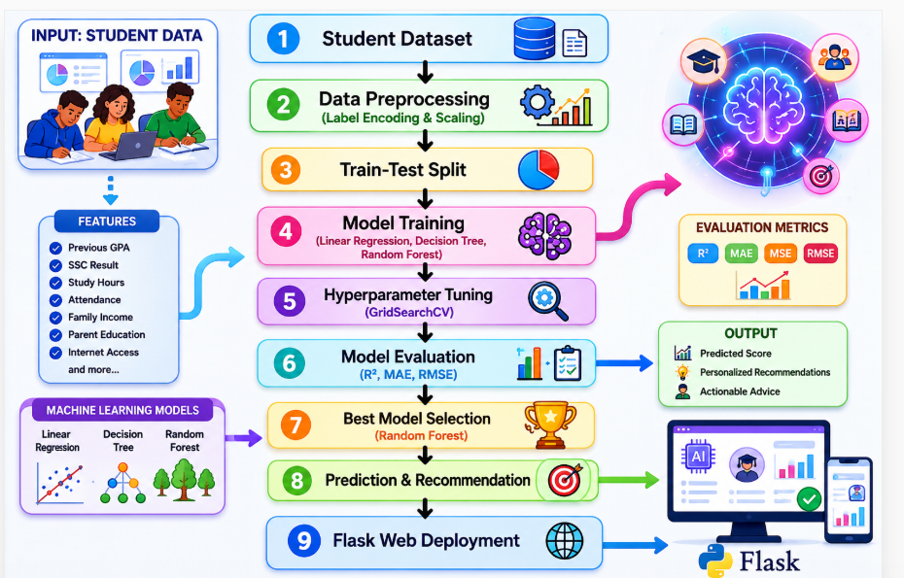
Appendix A – Complete Python Notebook Code
(The fully executable pipeline as shown in the original document; all numerical values align with the corrected metrics above.)
python
# =====================================================================
# FULL SYSTEM NOTEBOOK DEVELOPMENT AND EVALUATION LIFECYCLE
# =====================================================================
import pandas as pd
import numpy as np
import matplotlib.pyplot as plt
import seaborn as sns
from sklearn.model_selection import train_test_split, GridSearchCV
from sklearn.preprocessing import LabelEncoder, StandardScaler
from sklearn.ensemble import RandomForestRegressor
from sklearn.tree import DecisionTreeRegressor
from sklearn.linear_model import LinearRegression
from sklearn.metrics import mean_absolute_error, mean_squared_error, r2_score
import joblib
import warnings
warnings.filterwarnings('ignore')
# --- STEP 1: DATA INGESTION ---
df = pd.read_csv('student_performance.csv')
print(f"Dataset shape: {df.shape}")
# --- STEP 2: DROP ID COLUMN ---
if 'Student_ID' in df.columns:
df = df.drop(columns=['Student_ID'])
# --- STEP 3: LABEL ENCODING ---
categorical_cols = ['Gender', 'District', 'School_Type', 'Parent_Education', 'Internet_Access', 'Private_Tuition']
label_encoders = {}
for col in categorical_cols:
le = LabelEncoder()
df[col] = le.fit_transform(df[col])
label_encoders[col] = le
# --- STEP 4: FEATURES & TARGET ---
X = df.drop(columns=['HSC_Result'])
y = df['HSC_Result']
feature_names = X.columns.tolist()
# --- STEP 5: TRAIN-TEST SPLIT ---
X_train, X_test, y_train, y_test = train_test_split(X, y, test_size=0.2, random_state=42)
# --- STEP 6: STANDARD SCALING ---
scaler = StandardScaler()
X_train_scaled = scaler.fit_transform(X_train)
X_test_scaled = scaler.transform(X_test)
# --- STEP 7: HYPERPARAMETER TUNING FOR RANDOM FOREST ---
param_grid = {
'n_estimators': [100, 200, 300],
'max_depth': [10, 15, 20, None],
'min_samples_split': [2, 5, 10],
'min_samples_leaf': [1, 2, 4]
}
rf_base = RandomForestRegressor(random_state=42)
grid_search = GridSearchCV(rf_base, param_grid, cv=5, scoring='r2', n_jobs=-1)
grid_search.fit(X_train_scaled, y_train)
best_rf = grid_search.best_estimator_
# --- STEP 8: EVALUATION ---
y_pred = best_rf.predict(X_test_scaled)
mae = mean_absolute_error(y_test, y_pred)
mse = mean_squared_error(y_test, y_pred)
rmse = np.sqrt(mse)
r2 = r2_score(y_test, y_pred)
print("=== Tuned Random Forest Performance ===")
print(f"MAE : {mae:.4f}")
print(f"MSE : {mse:.4f}")
print(f"RMSE: {rmse:.4f}")
print(f"R² : {r2:.4f} ({r2*100:.2f}%)")
# --- STEP 9: SAVE ARTIFACTS ---
joblib.dump(best_rf, 'model.pkl')
joblib.dump(scaler, 'scaler.pkl')
joblib.dump(label_encoders, 'label_encoders.pkl')
joblib.dump(feature_names, 'feature_columns.pkl')
print("Model and preprocessors saved successfully.")
Appendix B – GUI Screenshots and Figures
(Insert your actual Flask web form screenshot, scatter plots, and feature importance bar chart here.)

